[Thank you for purchase product | Prepare4Exams](https://www.prepare4exams.com/order-confirmation.php?id=P4E-3062)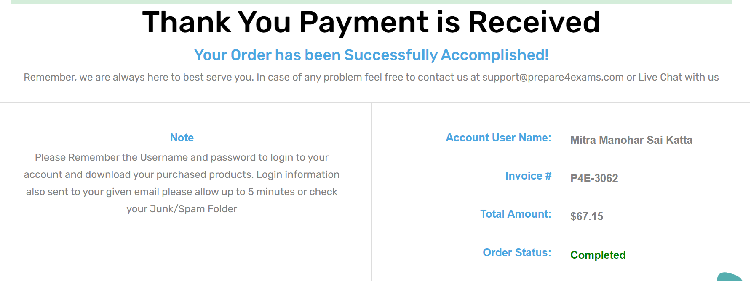

<https://docs.databricks.com/clusters/configure.html#spark-configuration>

<https://www.databricks.com/session_na21/productionizing-unstructured-data-for-ai-and-analytics>

<https://www.databricks.com/session/sparser-faster-parsing-of-unstructured-data-formats-in-apache-spark>

<https://ch-nabarun.medium.com/process-unstructured-data-using-pyspark-53807e703195>

<https://www.youtube.com/watch?v=_vLIoV8JDL4>

Import Notebook:

<https://flrs.github.io/spark_practice_tests_code/#2/44.html>

Deep dive into delta lake:

<https://www.youtube.com/watch?v=de-6a6Bfw6E&t=3s>

Live coding seesion with jack on delta lake

<https://www.youtube.com/watch?v=lBE6IU1s5Gw>

unpacking transaction logs:

<https://www.youtube.com/watch?v=F91G4RoA8is&t=383s>

Enforcing and evolving the schema:

<https://www.youtube.com/watch?v=tjb10n5wVs8&t=288s>

DELETE, UPDATE AND MERGE :

<https://www.youtube.com/watch?v=7ewmcdrylsA&t=402s>

Shift + enter- Execute current cell and go to next cell  
control + enter- Execute current cell and stay in current cell

[Home | Delta Lake](https://delta.io/)

Share the slide deck on comparison between databricks and snowflake:

<https://spark.apache.org/docs/latest/cluster-overview.html>

<https://www.youtube.com/c/AdvancingAnalytics>

<https://en.wikipedia.org/wiki/Z-order_curve>

[Data skipping with Z-order indexes for Delta Lake | Databricks on AWS](https://docs.databricks.com/delta/data-skipping.html)

question - when table is huge, Will rollback vs recreating table using older version be better

Vaccum can also be used in case of files which refers to versions older than a month

for externally managed tables

data n metadata will go, metadata will drop, data will remain, metadata will drop only

Working with DE 3.2B - Views and CTEs on Databricks, Cont

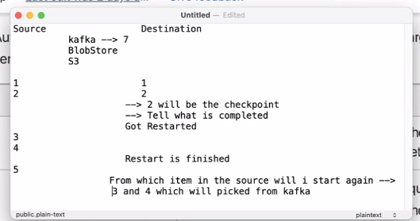

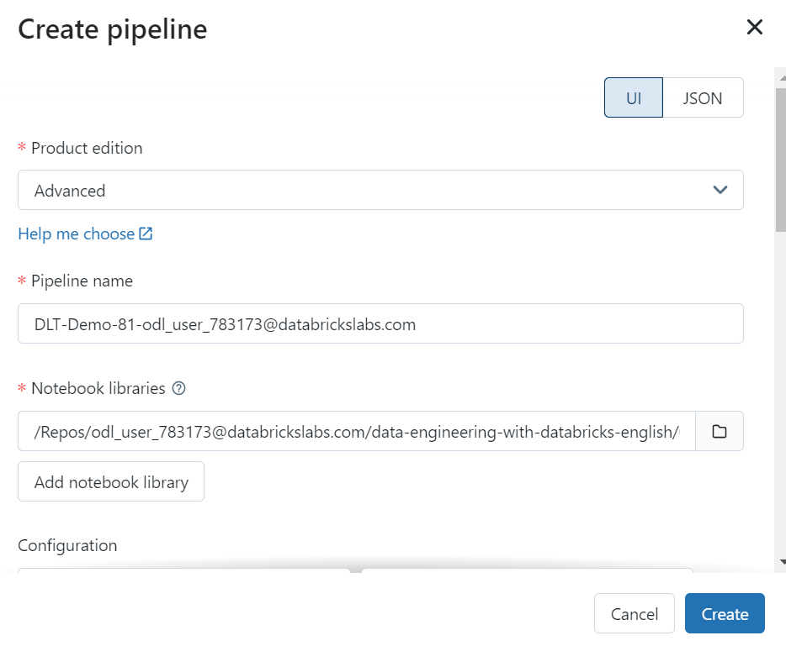

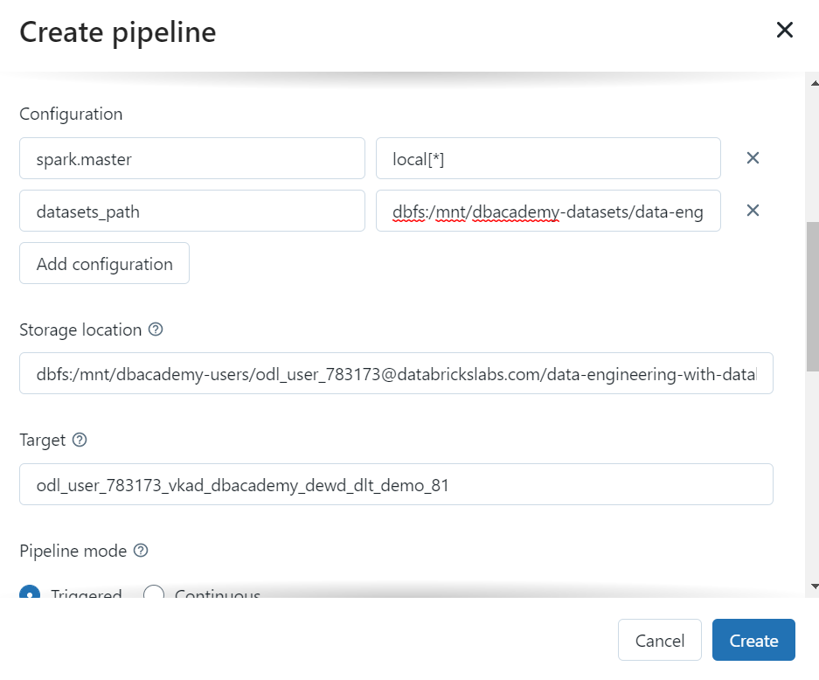

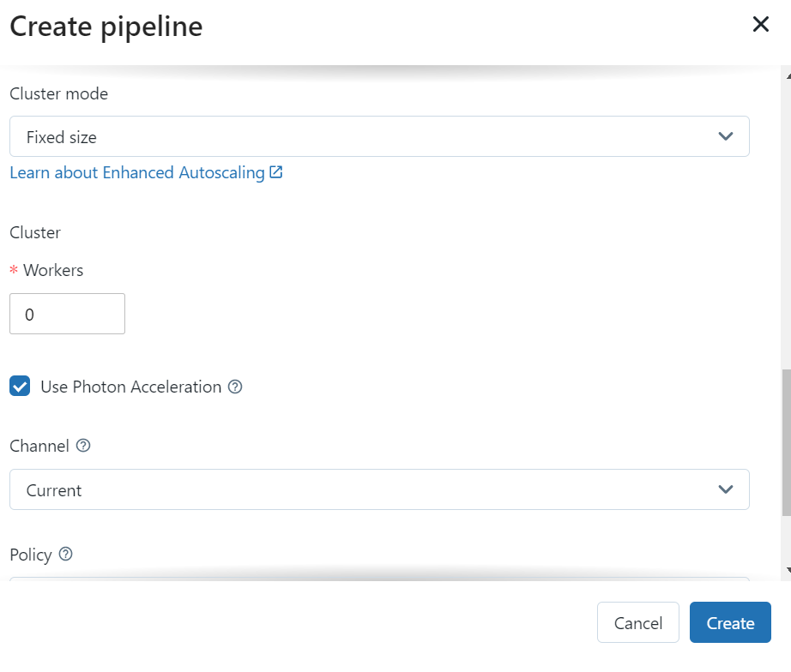

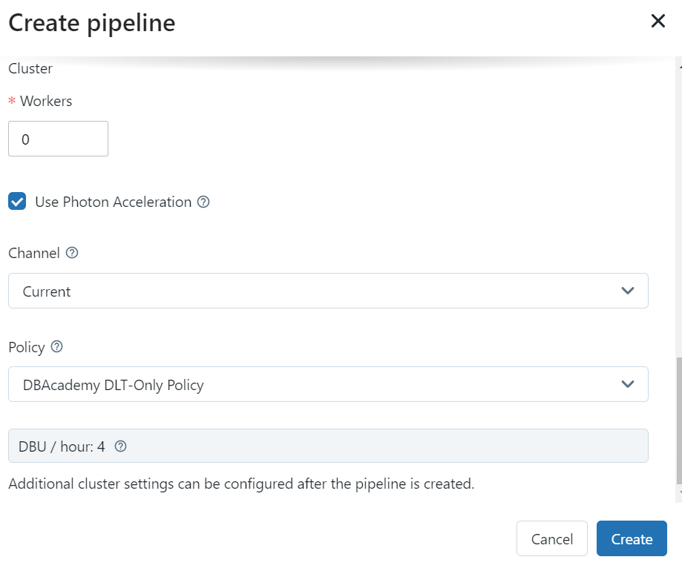

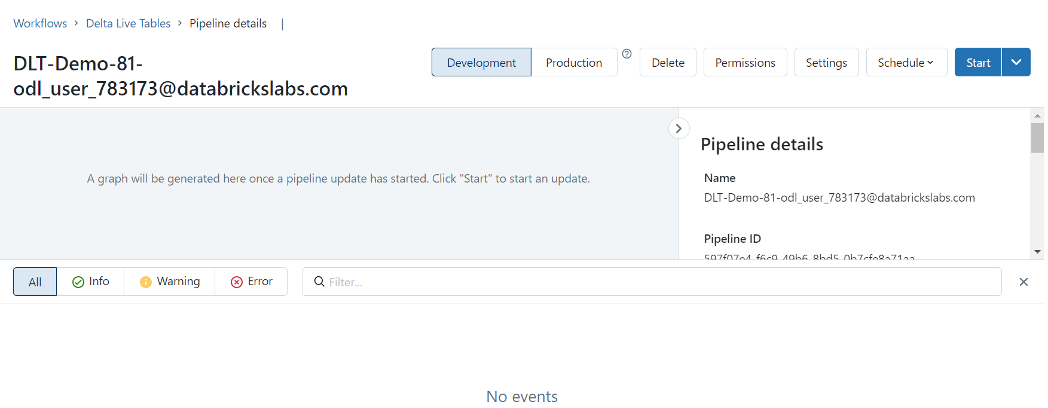

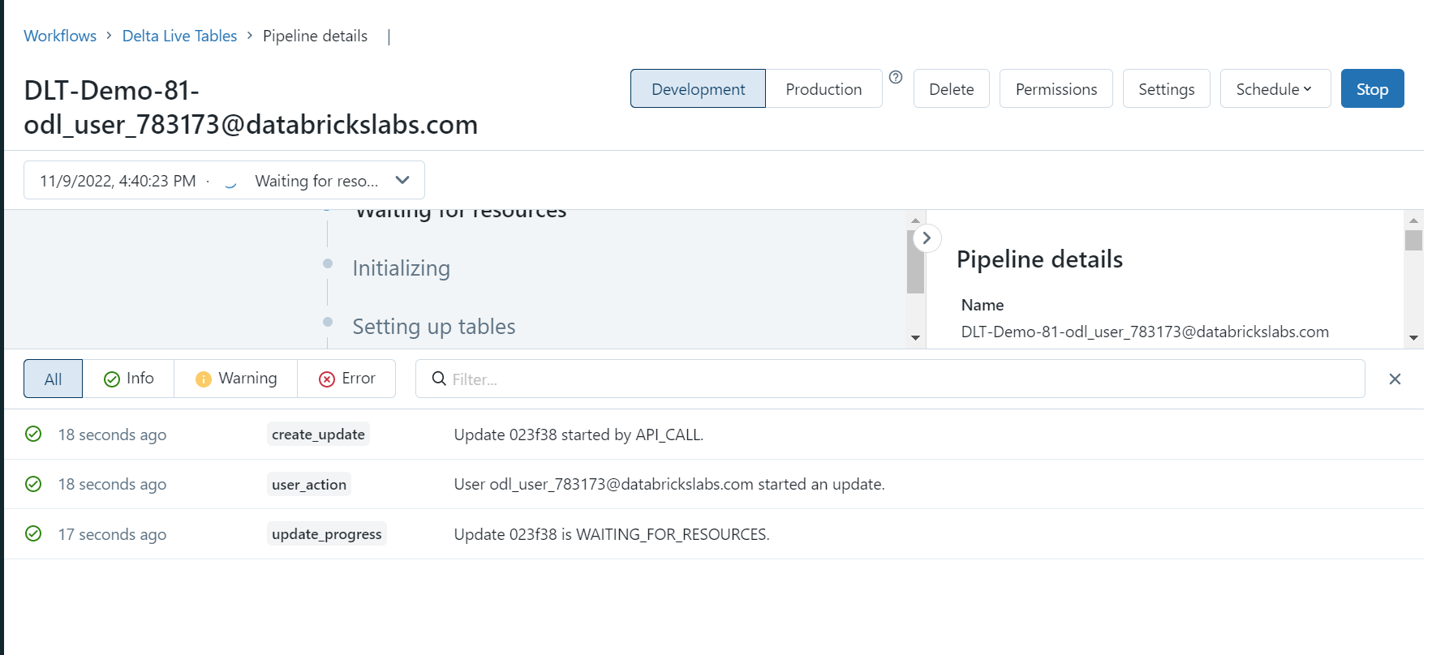

**Pipeline details**

|  |  |
| --- | --- |
| **Name** | DLT-Demo-81-odl_user_783173@databrickslabs.com |
| **Pipeline ID** | 597f07e4-f6c9-49b6-8bd5-0b7cfe8a71aa |
| **Paths** | [/Repos/odl_user_783173@databrickslabs.com/data-engineering-with-databricks-english/08 - Delta Live Tables/DE 8.1 - DLT/DE 8.1.2 - SQL for Delta Live Tables](https://adb-5452879900833533.13.azuredatabricks.net/?o=5452879900833533#workspace/Repos%2Fodl_user_783173%40databrickslabs.com%2Fdata-engineering-with-databricks-english%2F08%20-%20Delta%20Live%20Tables%2FDE%208.1%20-%20DLT%2FDE%208.1.2%20-%20SQL%20for%20Delta%20Live%20Tables) |
| **Run as** | odl_user_783173@databrickslabs.com |

**Update details**

|  |  |
| --- | --- |
| **Update ID** | 023f3875-bdc3-4f23-b981-d02b643197c1 |
| **Status** | Waiting for resources |
| **Update type** | Refresh all |
| **Creation time** | 11/9/2022, 4:40:23 PM |
| **Duration** | 1m 32s |

**Compute**

|  |  |
| --- | --- |
| **Cost** | DBU / hour: 4 |
| **Cloud** | Azure |
| **Product edition** | Advanced |
| **DBR version** | 11.0 |
| **Channel** | Current |
| **Policy** | [DBAcademy DLT-Only Policy](https://adb-5452879900833533.13.azuredatabricks.net/?o=5452879900833533#setting/clusters/cluster-policies/view/D063493FD8000F7C) |
| **Cluster** |  |

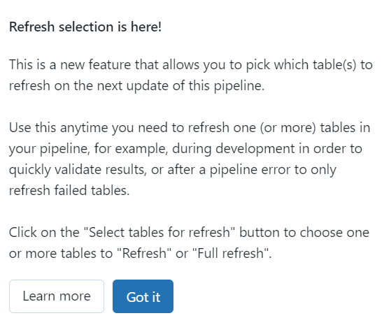

|  |
| --- |
|  |
| Pipeline Name: |  |
| Target: |  |
| Storage Location: |  |
| Notebook Path: |  |
| Datasets Path: |  |
| Policy: |  |

Pipeline Name: DLT-Demo-81-odl_user_783173@databrickslabs.com

Target: odl_user_783173_vkad_dbacademy_dewd_dlt_demo_81

Storage Location: dbfs:/mnt/dbacademy-users/odl_user_783173@databrickslabs.com/data-engineering-with-databricks/dlt_demo_81/storage

Notebook Path: /Users/odl_user_783173@databrickslabs.com/data-engineering-with-databricks/08 - Delta Live Tables/DE 8.1 - DLT/DE 8.1.2 - SQL for Delta Live Tables

Datasets Path: dbfs:/mnt/dbacademy-datasets/data-engineering-with-databricks/v02

Policy: DBAcademy DLT-Only Policy

CREATE OR REPLACE TABLE weather_managed AS

SELECT *

FROM parquet.`${DA.paths.datasets}/weather/StationData-parquet`